1. **Required Scenarios**

**Demonstrate a new employee created with create date / by populated. Return value should be IDENTITY value EmployeeID.**

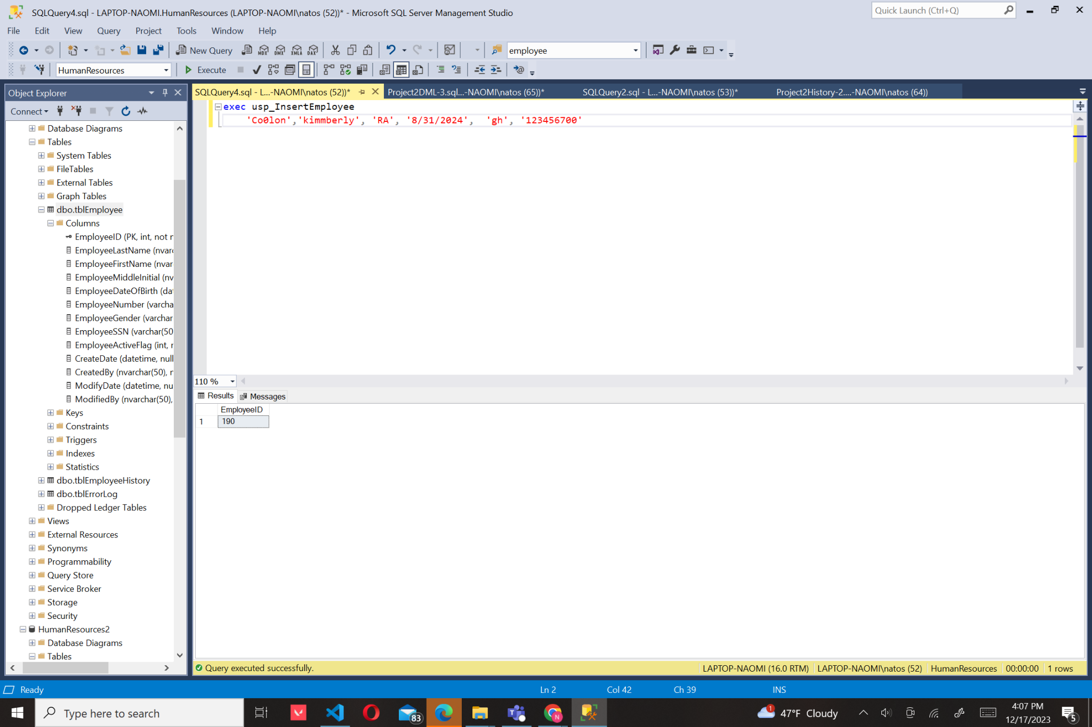

1. **Demonstrate an employee updated with modify date / by are populated.**

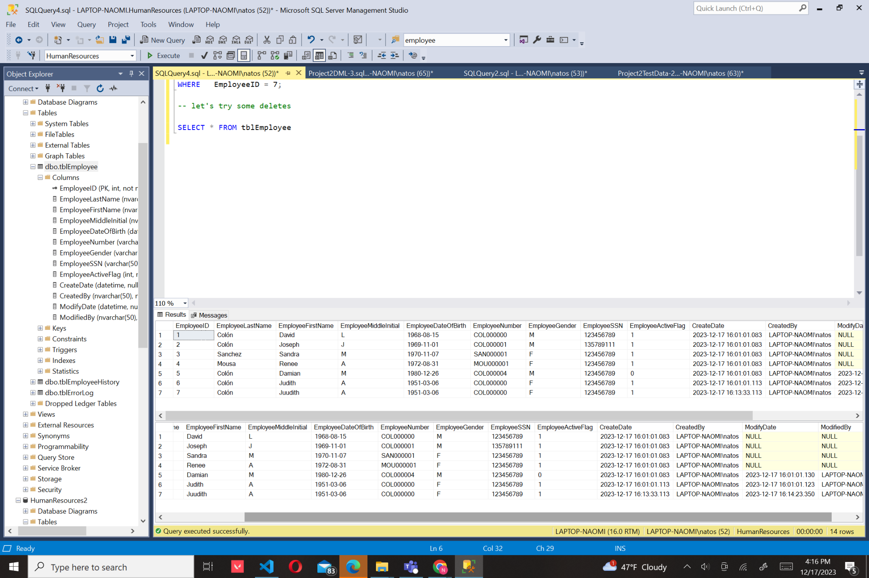

1. **Demonstrate a new employee that violates business rules for our table.**

**o DO THIS FOR ALL Columns except for the following**

**EmployeeID**

**Create Date / By**

**Modify Date / By**

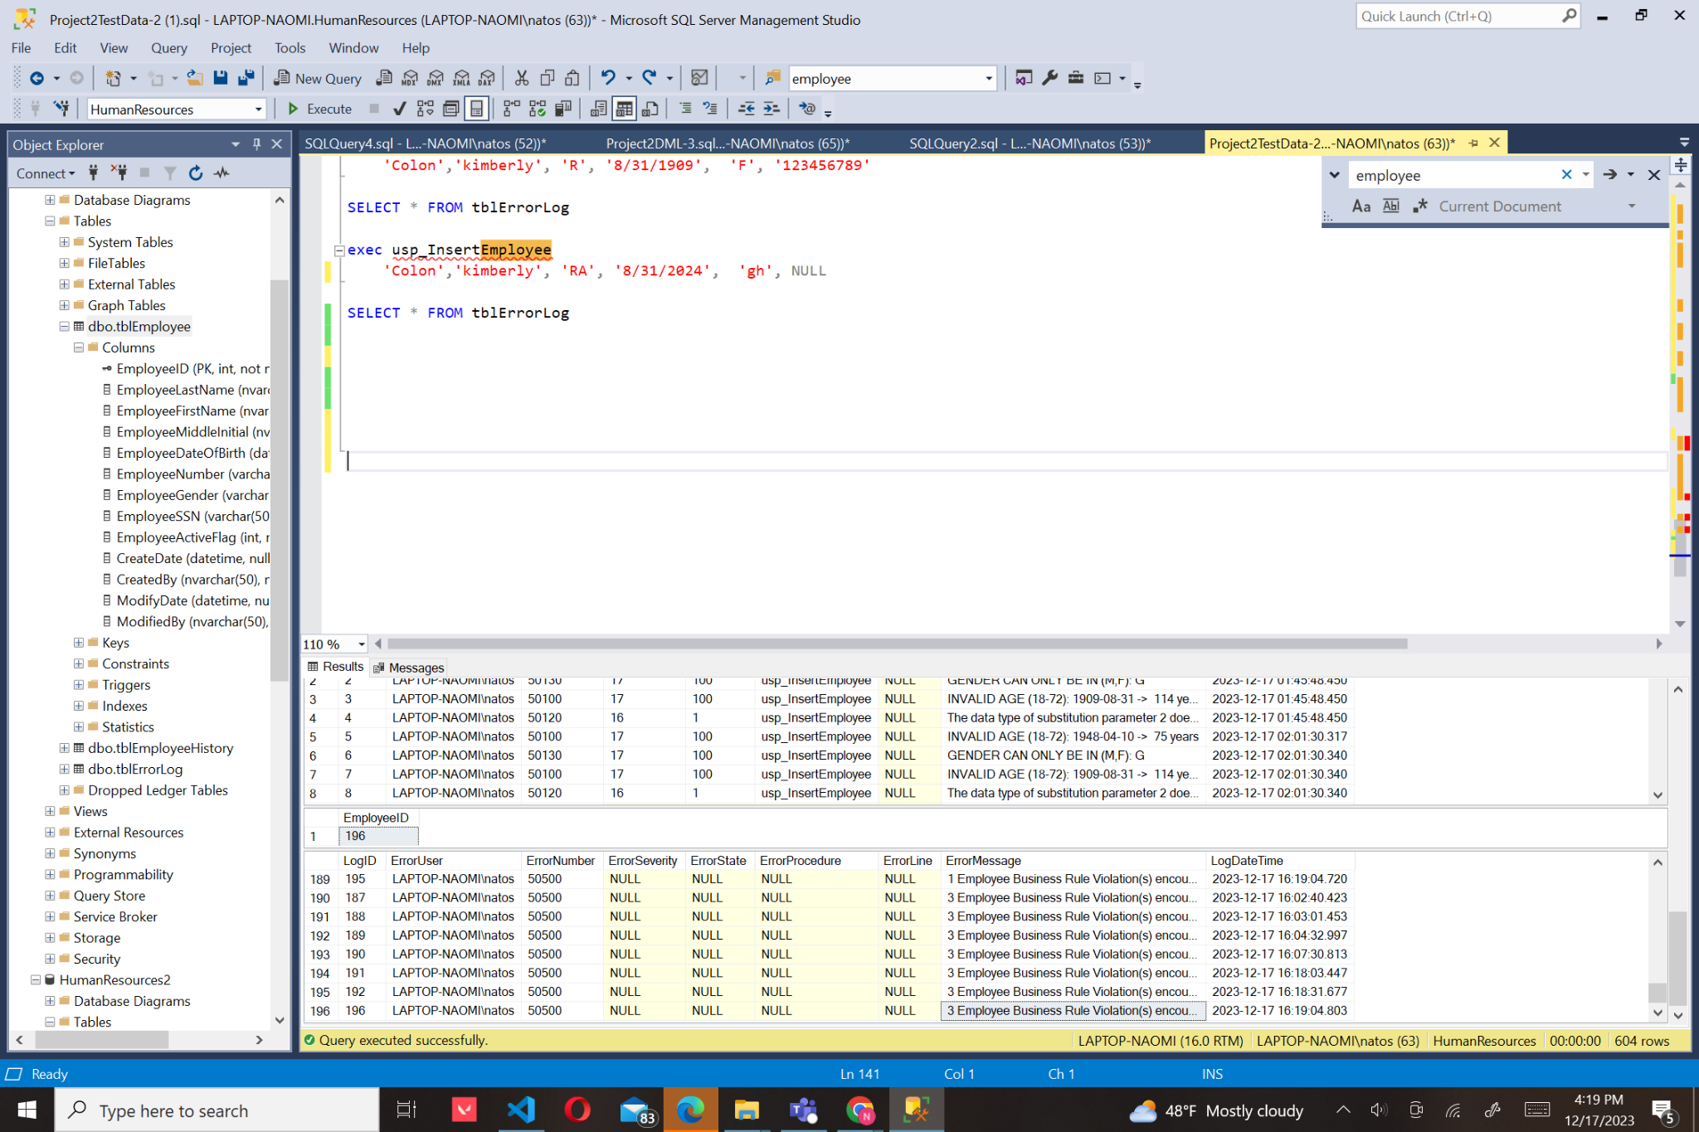

Error message for business rules: ErrorMessage

3 Employee Business Rule Violation(s) encountered: 50130 GENDER CAN ONLY BE IN (M,F): gh 50100 INVALID AGE (18-72): 2024-08-31 -> -1 years 50120 MIDDLE INITIAL LENGTH(1 MAX): RA -> 2

Tab and spacing applied

1. **Demonstrate deleting an employee is NOT a physical, but a logical delete.**

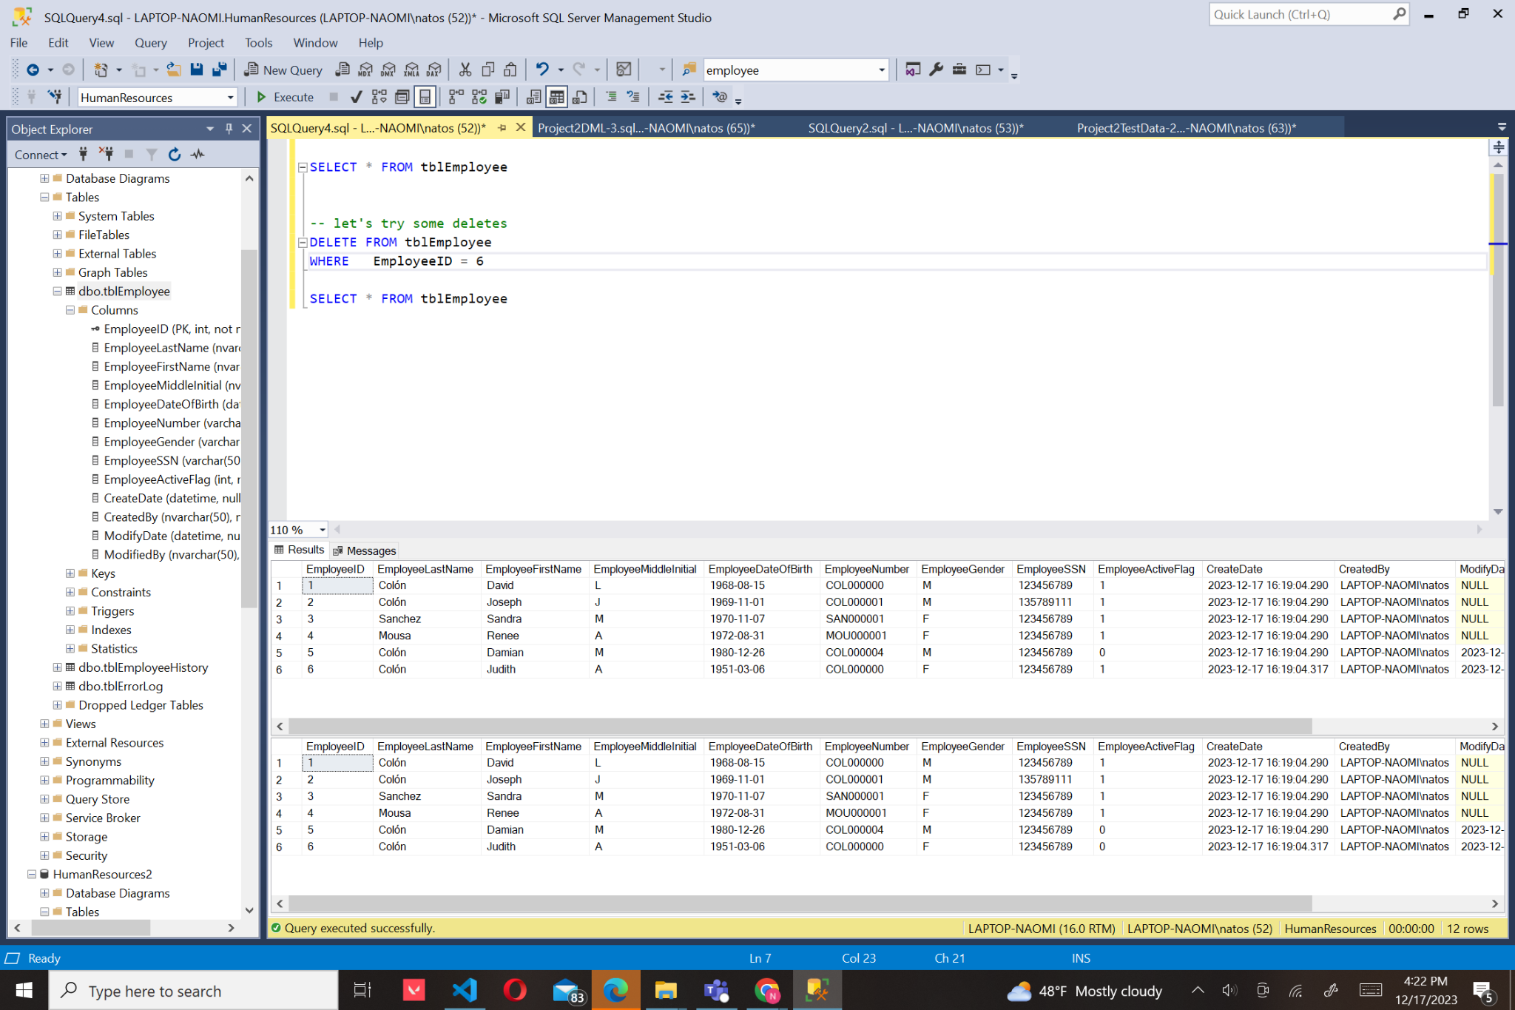

1. **Demonstrate an employee update that violates business rules for our table.**

**o DO THIS FOR ALL Columns except for the following**

**EmployeeID**

**Create Date / By**

**Modify Date / By**

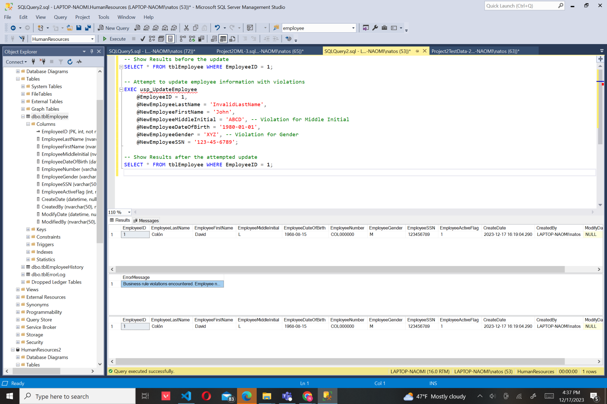

1. **Demonstrate that employee history is populated as employee record CRUD operations are performed**

